Small one bedroom apt. in Absecon. Furnished, ready for you to move right in, all you need bring is your toothbrush. Perfect for one person, no pets, no smoking. Quiet neighborhood
Call 609 432 9112 for info and appt. $675 plus elec.
Absecon, NJ
Call 609 432 9112

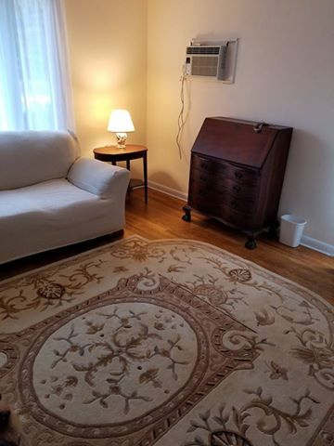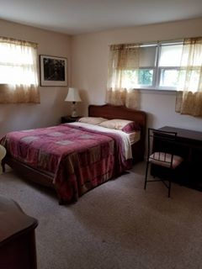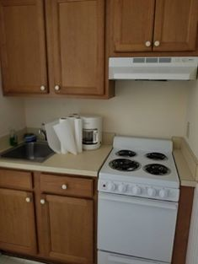

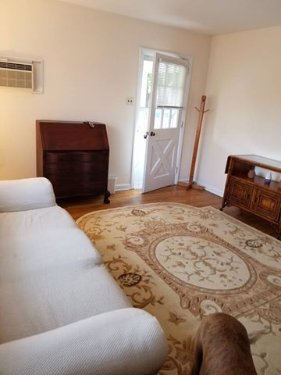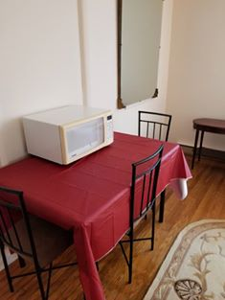 Call 609 432 9112

Post to More Places

